Heaven’s Light is Our Guide

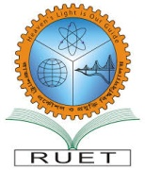

**RAJSHAHI UNIVERSITY OF ENGINEERING & TECHNOLOGY**

**Course Number : CSE 4204**

**Course Title : Sessional Based on CSE 4203**

**Submitted To:**

**Course Teacher : Dr. Md. Rabiul Islam**

**Professor**

**Department of Computer Science and Engineering**

**Rajshahi University of Engineering & Technology**

**Submitted By:**

**Name : Kazi Mehrab Rashid**

**Section : A**

**Roll No : 1703003**

**Department : Computer Science & Engineering**

**Institution : Rajshahi University of Engineering & Technology**

**Submission Date : 10/06/2023**